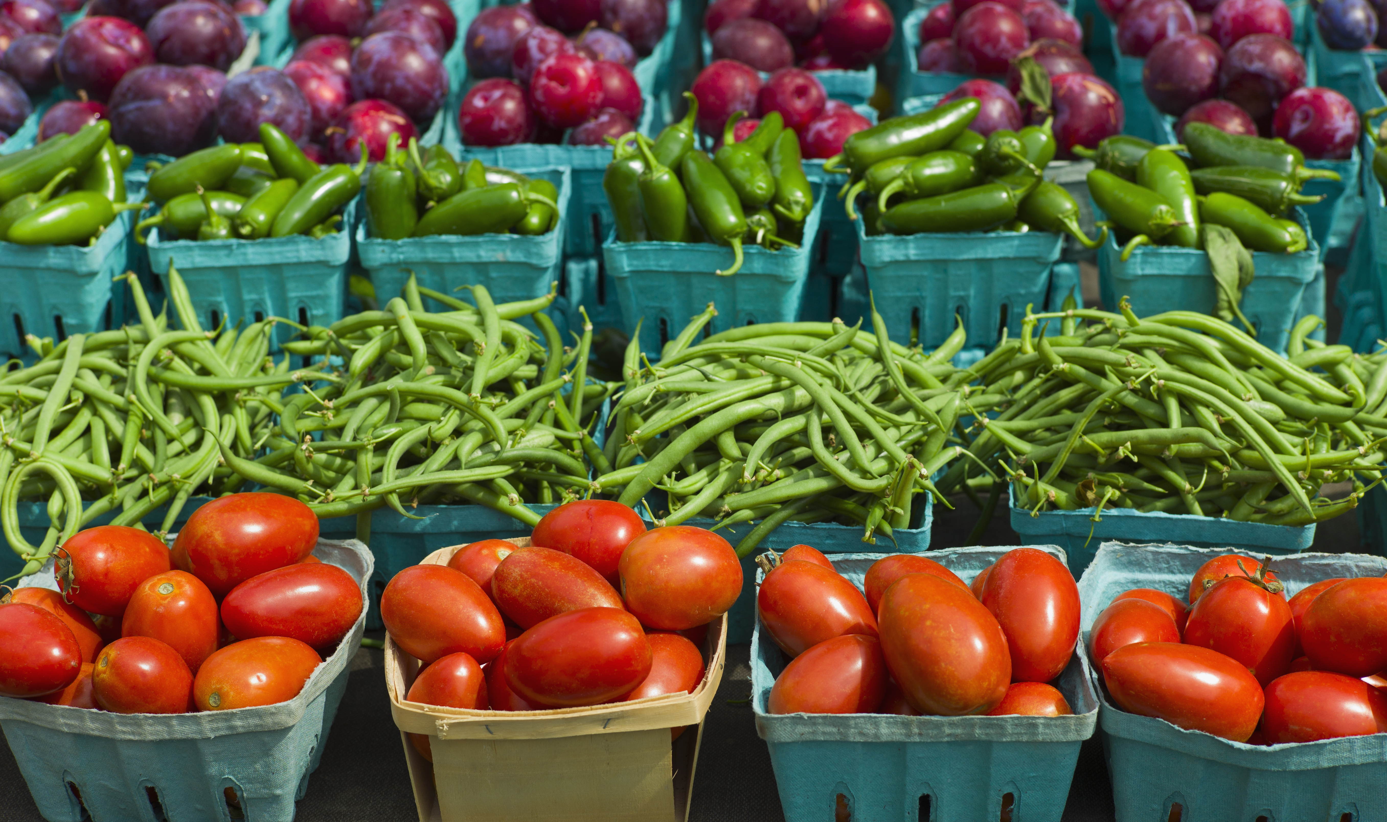

Farmer’s market

Produce – vendors
SATURDAYS 9am-1pm
June - October
Germantown Crossing - South end of parking lot
Jubilee lane • Germantown Hills, IL
support your community and local businesses, farmers, and vendors

For more information, or to become a vendor, please call or email:
309.383.2209
villagehall@mtco.com

